**18 Jan 2019** **The Weekly Bulletin of Rotary Club of Kathmandu Mid-Town** **bc-17.1/019**

|  |
| --- |
| C:\Users\Public\Documents\RIP T1819_EN.png |

District: 3292 Web:www.rotarymidtown.org.np Club Id: 26776

**JANUARY IS VOCATIONAL SERVICE MONTH**

**Vocational Service** has the purpose of promoting high ethical standards in businesses and professions, recognizing the worthiness of all dignified occupations, and fostering the ideal of service in the pursuit of all vocations.

The role of members includes conducting themselves and their businesses in accordance with Rotary’s principles and lending their vocational skills to club-developed projects in order to address the issues and needs of society.

**Weekly Meeting # 1472: Friday 11 Jan 2019**

In-house speaker IPP Bhairaja Panday talked on different aspects of Nepal-India relations.

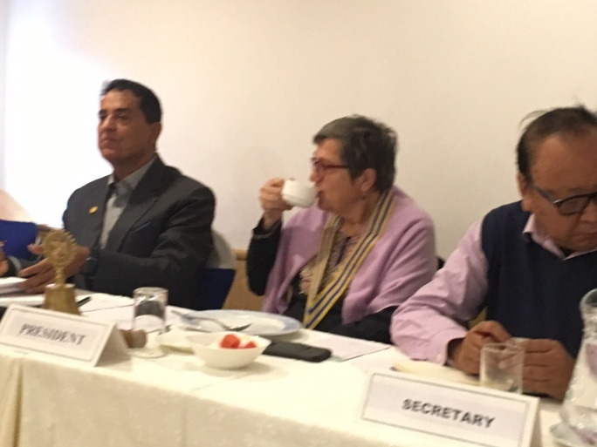 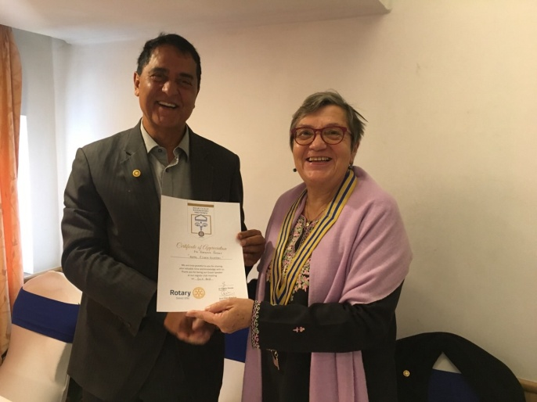

*Photo courtesy: Rtn Shyam R Thapalia*.

**Weekly Meeting # 1473 on Friday, 18 Jan 2019**

Our guest speaker is **Dr Birat Simba**. His topics of the talk is ‘Mental Health in Nepal.’

Dr Birat Simba has been with the United Nations in six different countries before he retired and returned to Nepal in 2007. During his time with UN he worked with UNDP, mainly with the United Nations Population Fund (UNFPA) for a total of 30 years. Since 2008, he was engaged in the mental health field here as an advocate to raise awareness and lower stigmatization. He graduated from St. Xavier’s School, Kathmandu: and completed his graduate and post-graduate college studies in the US.

**District Conference:**

Each year, districts are asked to hold a conference for club members so they can learn about what's happening in Rotary and their district and meet other Rotarians in the area. The conference usually lasts one to two days and includes:

- A visit from a president's representative, who gives an update on Rotary International and inspires and

motivates participants.

- A report on the district, including its successes and challenges.

- An official business meeting to discuss and vote on important district matters.

- Local and international speakers giving information on topics relevant to district members.

- Time to network, reconnect with friends, and find inspiration for continuing service & community leadership.

**11th District Conference of RI District 3292**

**is going to be held in Butwal, Gandaki Province**

**from 22 to 24 February 2019.**

**2019-20 RI President announces his presidential theme:**

Rotary International President-elect Mark Daniel Maloney announces the 2019-20 presidential theme,

***Rotary Connects the World***, to incoming district governors at Rotary’s annual training event, the International Assembly, in San Diego, California, USA, on Monday.

RIPE Mark Maloney explained his vision for building a stronger Rotary, calling on leaders to expand connections to their communities and to embrace innovative membership models.

“The first emphasis is to grow Rotary - to grow our service; to grow the impact of our projects; but, most importantly, to grow our membership so that we can achieve more,” Maloney said.

*- www.rotary.org*

**RI President-Elect:**

RI President Elect Mark Daniel Maloney is a member of the law firm of Blackburn,

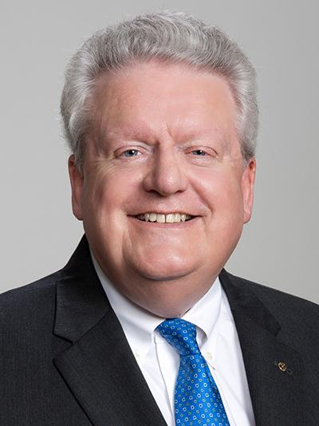

Maloney, and Schuppert LLC in Decatur, Alabama, practicing in the areas of

taxation, estate planning, and agricultural law. A Rotarian since 1980, Mark is a Past

President of the Rotary Club of Decatur and served as Governor of District 6860 in

1989-90. Mark also served as a member of the Board of Directors of Rotary

International in 1999-2001 and as the Aide to Jonathan Majiyagbe of Nigeria (RIP

2003-04). Mark was Vice Chairman of the 2004 Council on Legislation, Chairman of

the 2010 COL, and Parliamentarian/Trainer for the 2016 COL. He served as a

Trustee of the Rotary Foundation in 2004-08 and was the Vice Chairman of the

Trustees in 2006-07 and 2007-08. He is a recipient of the Citation for Meritorious

Service and the Distinguished Service Award presented by the Trustees of The

Rotary Foundation.

Mark’s wife, Gay, is an attorney at the same firm and a charter member and Past President of the RC of Decatur Daybreak, Alabama. Both Mark and Gay are Paul Harris Fellows, Benefactors, and Major Donors of The Rotary Foundation and members of its Bequest Society. They have two daughters, one goddaughter, and two grandsons.

*- www.rotary.org*

**Do you Know** **?**

A new state of matter exists (alongside solid, liquid and gaseous states) and it is known as [time crystals](https://www.nature.com/articles/nature21413)**.**  Created in the lab, the outrageously hard-to-grasp **time crystals** are structures that repeat periodically in time rather than space, potentially defying the laws of physics.

**A THOUGHT FOR THE DAY**

If we want boys to succeed, we need to bring them back to education by making education relevant to them and bring in more service learning and vocational education. *Michael Gurian*

On Lighter Side:

One of my friends was dating a blonde girl that wasn't too bright to say the least. Often she would come up with the most stupid comments that at first got us all laughing, but after a while also became a bit annoying to some.

One day we were sitting in a pool hall talking. The blonde participated in the discussion, and when she came up with an, even for her, unusually stupid comment one of my friends couldn't take it anymore.

So he said to her "You must have vacuum in your head".

This upset her. She looked at him for a couple of seconds and replied, "At least it's better than nothing."

Paul Harris put it this way: "Each Rotarian is the connecting link between the idealism of

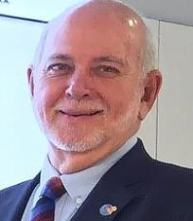

Rotary and his trade or profession." It was true when he said it and should be equally true

now. We only spend an hour or two a week at our Rotary meetings, but most of us spend

most of our waking time at work. Through Rotary, those hours are also an opportunity for

service: a chance to Be the Inspiration to those we work with, those who work for us, and

the communities we serve.

**RI President Barry Rassin**

Please send information on club activities, progress reviews on service projects, relevant photos etc to:

BC Editor: RR Shrestha email: rryesrr@gmail.com

## 18 Jan 2019 The Weekly Bulletin of Rotary Club of Kathmandu Mid-Town bc-17.1/019